HERO STEELS LIMITED
Cold Rolling Steel Plant · Digital Transformation Initiative

MODULE M1 — DATA CAPTURE LAYER
M1-04 · Document 5 of 10
Data Model & Database Design
Master, transaction, reference, user, audit and planning tables; ER diagrams; keys, relationships and the runnable SQL DDL
Document set — M1 Technical Blueprint
Doc | Title
M1-00 | Blueprint Overview & Index
M1-01 | System Architecture
M1-02 | Process-Wise Data Capture Design
M1-03 | UX Design & Operator Workflow
M1-04 | Data Model & Database Design
M1-05 | Role-Based Access Control & Security
M1-06 | Planning Integration & Export
M1-07 | Validation Framework
M1-08 | Audit Trail & Compliance
M1-09 | Reporting & Monitoring
Prepared for Z Company · Role: Manufacturing Digital Transformation Consultant / Industrial Software Architect
Version 1.0 · 30 May 2026 · Confidential

Contents

1. Modelling Principles
The data model turns the mapping phase's 115 canonical fields into a normalised, modular schema. Three rules drive every table: one canonical field is one column (with its unit embedded in the name); one real-world entity has exactly one master; and the coil is the atomic, shared spine that every process appends to. The result de-duplicates the 317 paper captures and gives downstream modules stable keys to join on.
Decision | Rationale
UPPER_SNAKE_CASE with unit suffix (e.g. COIL_WIDTH_MM) | Self-documenting; eliminates unit ambiguity across lines
One master per entity (customer, grade, defect, stoppage, operator, furnace) | Shared dropdowns; consistent codes; single point of maintenance
Coil = single normalised COIL_NO; parent/child for slitting | End-to-end traceability; slit genealogy preserved
Shared SHIFT_LOG header + per-process detail tables | Common fields once; process specifics isolated and independently evolvable
Repeatable sub-tables for stoppage / defect / crew | Scales to any line; no fixed Crew1/2/3 columns
Weight stored in MT plant-wide | CTL kg converted on entry; one unit for all roll-ups
Logical schemas (master/coil/txn/planning/security/audit) | Mirrors the modularity & access model; clean BI replica boundary

2. Schema Organisation
Schema | Holds | Change rate
master | Reference/master data shared by all forms | Slowly changing
coil | Coil identity & process history (traceability spine) | Per coil
txn | Shift logs, per-process entries, stoppage/defect/crew | High (append)
planning | SAP/CSV-sourced plan orders, coil plan, import batches | Per plan cycle
security | Users, roles, user-role, line access | Slowly changing
audit | Audit log, change requests, export jobs | Write-once

3. Entity-Relationship Diagrams
The model is shown in two ER views for legibility: the core capture & traceability entities, and the supporting planning, security and audit entities. Crow's-foot notation; PK underlined, FK italic.

3.1 Core capture & traceability
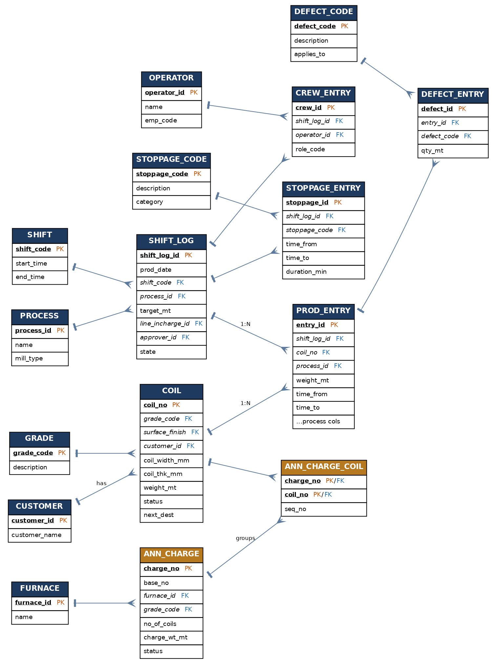
Figure. Core ER — coil spine, shift log, process entries, sub-tables and masters

3.2 Planning, security & audit
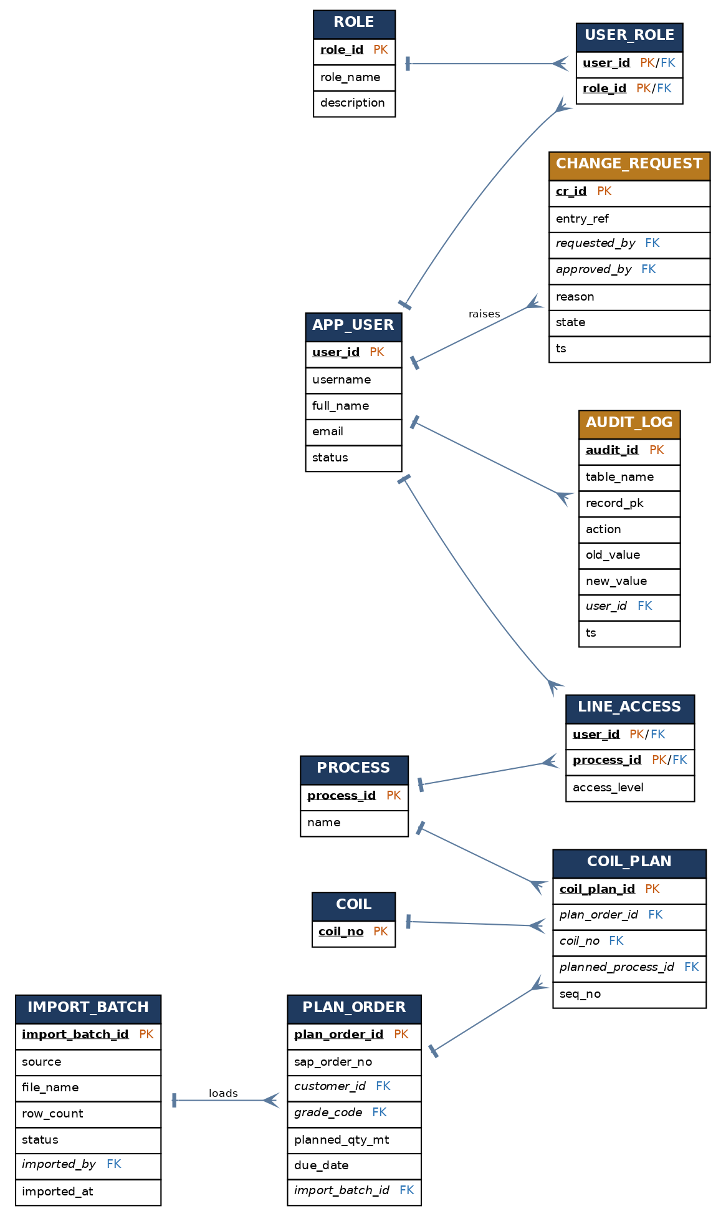
Figure. Supporting ER — planning, RBAC and audit/change control

4. Table Catalog
Forty tables across six schemas. The per-process detail tables (prod_*) all share the same shape — header link + coil link + the process-specific columns from M1-02.
Group | Tables | Primary key
Master | process, shift, customer, grade, surface_finish, defect_code, stoppage_code, operator, furnace, rp_oil_grade, grade_spec | code / id
Coil | coil, coil_process_history | coil_no
Txn – header & shared | shift_log, stoppage_entry, crew_entry, defect_entry | *_id
Txn – per process | prod_hrs (+ _slit), prod_pkl, prod_pkl_chart, prod_crm, ann_charge (+ _coil), prod_skp (+ _pass), prod_rwd, prod_crs (+ _slit), prod_ctl | entry_id / charge_no
Planning | import_batch, plan_order, coil_plan | *_id
Security | app_user, role, user_role, line_access | id / composite
Audit | audit_log, change_request, export_job | *_id

5. Key Table Structures
Selected structures in full; the rest follow the same conventions in the companion DDL.

5.1 coil.coil — the traceability spine
Column | Type | Key / notes
coil_no | VARCHAR(30) | PK — single normalised identity
parent_coil_no | VARCHAR(30) | FK → coil (self) — slitting parent
customer_id | INTEGER | FK → master.customer
grade_code | VARCHAR(20) | FK → master.grade
surface_finish | VARCHAR(8) | FK → master.surface_finish
heat_no | VARCHAR(30) | HT / heat number
nominal_width_mm / coil_width_mm | NUMERIC | nominal vs actual width
coil_thk_mm / weight_mt | NUMERIC | current thickness; weight in MT
current_process_id / next_dest | SMALLINT / VARCHAR | current location; routing (e.g. CTL)
status | VARCHAR(20) | PLANNED/IN_PROCESS/HOLD/REWORK/DONE/SCRAPPED

5.2 txn.shift_log — the transaction header
Column | Type | Key / notes
shift_log_id | BIGSERIAL | PK
prod_date / shift_code / process_id | DATE / FK / FK | unique together with mill_type
mill_type | VARCHAR(8) | 2HI/4HI/6HI — CRM only
target_mt / total_prod_mt | NUMERIC | target (plan); total derived
line_incharge_id / shift_manager_id | FK → operator | shift staffing
approver_id | FK → app_user | supervisor who locks
state | VARCHAR(16) | DRAFT/SUBMITTED/APPROVED/REOPENED
prev_shift_log_id | FK → shift_log (self) | handover link

5.3 Per-process entry pattern (e.g. txn.prod_crm)
Every prod_* table starts with the same three columns — entry_id (PK), shift_log_id (FK → header), coil_no (FK → spine) — then carries that process's specific columns from M1-02. prod_crm adds output_thk_mm, hardness, elongation, tension, rolls, oil and a CHECK that output thickness is less than input. Annealing differs: ann_charge is keyed by charge_no and ann_charge_coil resolves a charge to its coils.
Modular by construction
Adding a field to one line means altering one prod_* table. Adding a line means one new prod_* table plus a process master row — the shared header, sub-forms, masters and coil spine are untouched.

6. The Shared-Field Backbone (35 common master fields)
These recur across two or more processes and are defined once. They become the shared header, the coil/dimension columns, and the sub-table fields — the reason M1 has no duplicated definitions.
Canonical field | Label | Category | # proc | Appears in
PROD_DATE | Date | Shift Info | 8 | All processes
LINE_INCHARGE_ID | Line Incharge | Admin | 8 | All processes
OPERATOR_CODE | Operator | Operator | 8 | All processes
SHIFT_CODE | Shift | Shift Info | 8 | All processes
STOPPAGE_CODE | Stoppage Code | Downtime | 8 | All processes
APPROVER_ID | Area Manager | Admin | 7 | All except Annealing
COIL_NO | Coil Source / No. | Coil | 7 | All except Annealing*
CRANE_OPERATOR | Crane Operator | Operator | 7 | Most lines
CUSTOMER_ID | Customer | Coil | 7 | All except Annealing
GRADE_CODE | Grade | Coil | 7 | All except Pickling/Rewinding split
REMARKS | Remarks | Quality | 7 | Most lines
SL_NO | Sl. No. | Production | 7 | Most lines
TARGET_MT | Target (MT) | Production | 7 | Most lines
TIME_TOTAL_MIN | Time Taken – Total | Production | 7 | Most lines (derived)
TOTAL_PROD_MT | Total Production (MT) | Production | 7 | Most lines (derived)
WEIGHT_MT | Weight | Production | 7 | Most lines
CREW | Crew 1/2/3 | Operator | 6 | → repeatable crew sub-table
COIL_WIDTH_MM | Width | Coil | 6 | PKL, CRM, SKP, RWD, CRS, CTL
DEFECT_CODE | Defect Code/Symbol | Quality | 4 | HRS, PKL, CRM, CTL
STOPPAGE_DURATION | Stoppage From/To/Total | Downtime | 4 | HRS, PKL, CRM, ANN
COIL_THK_MM | Thickness | Coil | 4 | PKL, CRM, SKP, RWD
DOC_FORM_NO | Form No. | Admin | 3 | HRS, CRS, CTL
HOLD_MT | Hold | Downtime | 3 | SKP, CRS, CTL
OUTPUT_THK_MM | Output Thickness | Quality | 3 | CRM, SKP, RWD
REJECTION_MT | Rejection | Downtime | 3 | SKP, CRS, CTL
RW_TENSION_KG | R/W Tension | Process | 3 | CRM, SKP, RWD
ACTUAL_WIDTH_MM | Actual Width | Quality | 2 | HRS, CRS
ASST_OPERATOR | Asst. Operator | Operator | 2 | PKL, CTL
ELONGATION_PCT | Elongation | Quality | 2 | CRM, CRS
HARDNESS_HRB | Hardness VPN/HRB | Quality | 2 | CRM, CRS
HELPER | Helper | Operator | 2 | PKL, ANN
NOMINAL_THK_MM | Nominal Thickness | Coil | 2 | HRS, CRS
SCRAP_MT | Scrap (MT) | Downtime | 2 | HRS, CRM
SLIT_COMBINATION | Slit Combination A/B/C/D | Process | 2 | HRS, CRS
SURFACE_FINISH | Roll Finish (M/B) | Quality | 2 | SKP, RWD

7. Naming Convention (variant → standard)
The paper sheets recorded the same concept under different labels. The model normalises each to one standard name with an embedded unit.
Current variants | Standard name | Type | Unit | Notes
Coil No / Coil Source No / Coil M.T | COIL_NO | Text | — | Primary traceability key
Charge No, Base No (Annealing) | ANN_CHARGE_NO / ANN_BASE_NO | Text | — | Maps to constituent COIL_NO
Customer | CUSTOMER_NAME | Dropdown | — | Master list
Grade / Grd | GRADE_CODE | Dropdown | — | Split surface finish separately
Surface / Roll Finish (M/B) | SURFACE_FINISH | Dropdown | — | Matt / Bright
Width / Coil Width | COIL_WIDTH_MM | Numeric | mm | Nominal vs Actual as 2 fields
Thickness / Thick | COIL_THK_MM | Numeric | mm | Input thickness
Output/Final Thickness | OUTPUT_THK_MM | Numeric | mm | Achieved after rolling
Weight / Wt / Charge Wt | WEIGHT_MT | Numeric | MT | Standardise to MT
Hardness VPN/HRB | HARDNESS_VPN / _HRB | Numeric | VPN/HRB | Two fields
UTS | UTS_NMM2 | Numeric | N/mm² | Tension test
Line Speed | LINE_SPEED_MPM | Numeric | m/min | Grade-banded
R/W Tension | RW_TENSION_KG | Numeric | kg | Stage-wise sub-table
Acid/Iron Strength | ACID_STRENGTH_PCT / IRON_STRENGTH_PCT | Numeric | % | Per tank T1–T3
Temp (°C) | TEMP_DEGC | Numeric | °C | Context-prefixed (ANN_, RINSE_)
Scrap / Rejection / Hold | SCRAP_MT / REJECTION_MT / HOLD_MT | Numeric | MT | Separate disposition fields
Stoppage Code | STOPPAGE_CODE | Dropdown | — | Plant-wide coded master
Defect Code/Symbol | DEFECT_CODE | Dropdown | — | Plant-wide coded master
Operator/Crew/Helper | OPERATOR_CODE (role-tagged) | Dropdown | — | Repeatable crew sub-table
Time From/To/Total | TIME_FROM / TIME_TO / TIME_TOTAL_MIN | Time/Numeric | min | Total derived

8. Keys, Relationships & Integrity
- Traceability: coil_process_history(coil_no, process_id) records each step; parent_coil_no links slit children to their source.
- Header→detail: every prod_* and sub-table references shift_log_id; deleting a draft cascades to its details.
- Annealing grouping: ann_charge_coil(charge_no, coil_no) is the many-to-many that resolves a furnace charge to its coils.
- Masters: all coded fields (customer, grade, defect, stoppage, surface finish, oil grade, furnace) are FK-enforced — no free-text codes.
- Uniqueness: shift_log is unique on (date, shift, process, mill_type); slit/pass rows unique within their parent entry.
- Routing: prod_crs.for_ctl_mt > 0 sets coil.next_dest = CTL, surfacing the coil in the CTL plan list.

9. Performance, Partitioning & BI Separation
- Transaction tables (shift_log, prod_*, audit_log) are partitioned by prod_date / month; old partitions archive cheaply.
- Indexes on coil_no, (prod_date, process_id), grade_code, status and audit (table, record_pk) support capture and traceability queries.
- A streaming read replica serves all reporting (M1-09) so analytics never blocks capture.
- JSONB columns (e.g. export params, audit old/new value) keep flexible data without widening core tables.

10. Companion DDL
The complete, runnable schema is delivered as M1_schema.sql (PostgreSQL 15+). It creates the six schemas and all forty tables in dependency order, with primary/foreign keys, CHECK constraints (including output-thk < input-thk and pickling/annealing guards), indexes, a generic audit trigger function, and seed rows for the process and role masters. It parses cleanly and every foreign key resolves to an earlier table, so it can be applied top-to-bottom on a fresh database.

